**LECTURE 2 HANDOUT 1 – GRAPHS & CHARTS**

In 2011, an online language learning school conducted a survey on difficulties that people face when learning a new language. The survey was conducted using 16 000 language learners across 150 countries. The pie chart below summarises the results. Study the pie chart and then answer the questions that follow.

***What is thmain difficulty that you experience when learning a new language?***

11%

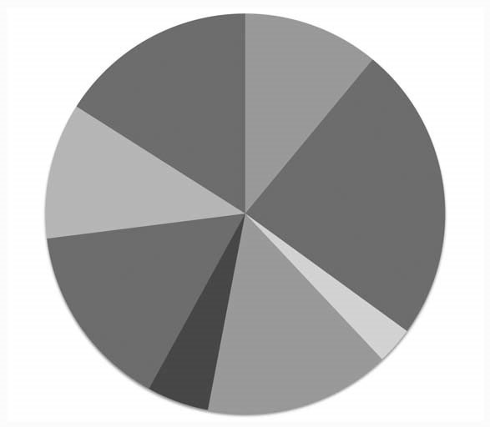

Not enough time

%

24

To keep up the

motivation

16

%

No access to

native speakers 15%

Not enough money

11

%

To feel ashamed

when speaking a

foreign language 11%

Bad teacher

3

%

Bad teaching method

15

%

No or limited access to

good learning material

5

%

15%

**Chapter 4**

Education

Source: https://s3.amazonaws.com/hackedu/busuu_survey.jpg

|  |
| --- |
| Of the people surveyed, 24% said they didn’t have enough time to learn a new language  and 11 % said they feel ashamed when speaking a foreign language  However, another 11% said they do not have enough money while 5 % had limited access to good learning material. Fifteen per cent of learners suffered from bad teaching methods and 3% were affected by bad teachers Another 15 % complained that they have no access to native speakers although 16 % admitted that they have to keep up the motivation Summarize the main problems faced by people learning a new language: .......................  ...................................................................................................................................................................  ................................................................................................................................................................... |

# 